WOMEN IN FILM, INDIA

Proposal for the Ministry of Information & Broadcasting

Objective
Get More Women More Jobs
WIF India is committed to fostering gender parity in the Indian entertainment industry
Together, we strive to create a platform where every woman in the entertainment industry has the opportunity:
To be heard,
To be seen,
To be able to work together,
To celebrate each other.

COVER LETTER
To
Ms. Nidarshana Gowani
Kamla Mills Foundation
Subject: Proposal for Collaboration on Women in Film India’s Internship Program
Dear Nidarshana,
It was a pleasure to connect recently, and thank you again for taking the time to meet with us. The conversation opened up a meaningful doorway of possibility, and I’m excited to now formally share with you a proposal from Women in Film India.
As you may know, Women in Film India is building a strong ecosystem to support women across all stages of their careers in film, television, OTT, and allied media. One of our flagship initiatives under the Education pillar is the Internship Program designed to place young women in hands-on, paid internships across key departments such as Direction, Writing, Editing, Cinematography, Production, Art, and even Entertainment Law. These internships are 3 to 6 months long, and include travel support, mentorship, and stipends to ensure accessibility for all backgrounds.
We believe this is a powerful opportunity to level the playing field for young women entering an often opaque and male dominated industry, and we would be honoured to have Kamla Mills Foundation as a founding supporter of this effort.
Enclosed is the detailed proposal. We hope it reflects the intent and impact we aim to deliver, and the alignment with your vision of building equitable, future forward platforms for women.
I would be happy to walk you through the proposal in detail or answer any questions you may have. We are very hopeful of building something meaningful together.
Warm regards,
Women in Film India

EXECUTIVE SUMMARY
Our objective is to increase women’s participation and leadership in the media sector by creating access to skill development, mentorship, and industry exposure.
Through this proposal, we seek funding support from the Ministry of Information & Broadcasting to implement a nationwide initiative comprising mentorship programs, workshops, and high-impact labs that will equip women with the skills and networks necessary to thrive in a rapidly evolving media landscape.
These programs are designed to build a strong talent pipeline, support mid-career women re-entering the workforce, and enhance India’s global creative reputation. With support from WIF LA and in collaboration with Indian industry leaders, we aim to foster local and international opportunities for Indian women in film, while also contributing to the Government’s broader vision of employment generation, capacity building, and cultural diplomacy

ABOUT WOMEN IN FILM, INDIA
Women in Film (WIF) India, supported by Women in Film Los Angeles (WIF LA) a globally recognized non-profit committed to advancing gender equity in media, is dedicated to empowering women across the Indian film, television, and digital content industries.
Women in Film (WIF) India is a national initiative committed to empowering women across the Indian film, television, and digital media industries. Our mission is to create a more inclusive and equitable ecosystem where women have equal opportunities to learn, lead, and thrive—across creative, technical, and leadership roles.
WIF India works to address the deep-rooted gender gap in media by:
- Providing mentorship and leadership development
- Conducting skill-building workshops and training programs
- Creating direct pathways to employment and industry access
Through a nationwide structure of programs including fellowships, labs, internships, and masterclasses WIF India is building a sustainable talent pipeline and supporting women at every stage of their careers.
With a clear focus on action and outcomes, WIF India is not just advocating for change, we are building the infrastructure to make it happen. Our goal is simple yet urgent:
Get More Women More Jobs.

OUR TEAM
Our team is composed of experienced professionals dedicated to advancing gender parity and empowering women in the Indian film and media industry. Each member brings unique expertise and a shared commitment to fostering inclusivity through impactful initiatives.
Guneet Monga
Producer & Founder
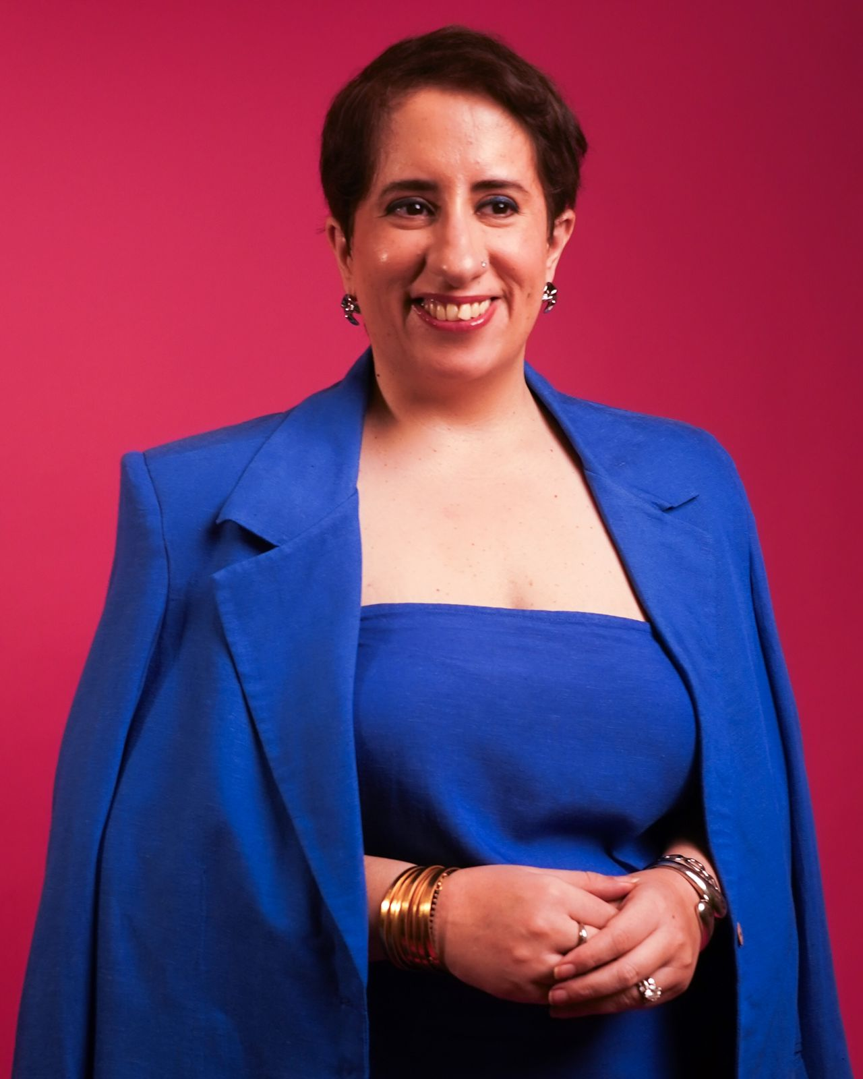
An Academy Award-winning producer, Guneet Monga is one of the most influential figures in the Indian film industry. With a diverse portfolio of successful films, Guneet’s work has not only redefined Indian cinema but also championed women’s voices in the industry. As the driving force behind the vision of bringing Women In Film to India, Guneet brings her unparalleled experience and passion for gender equality, making her an indispensable leader in pushing this initiative forward.

Rabia Chopra
Director of Program and Development
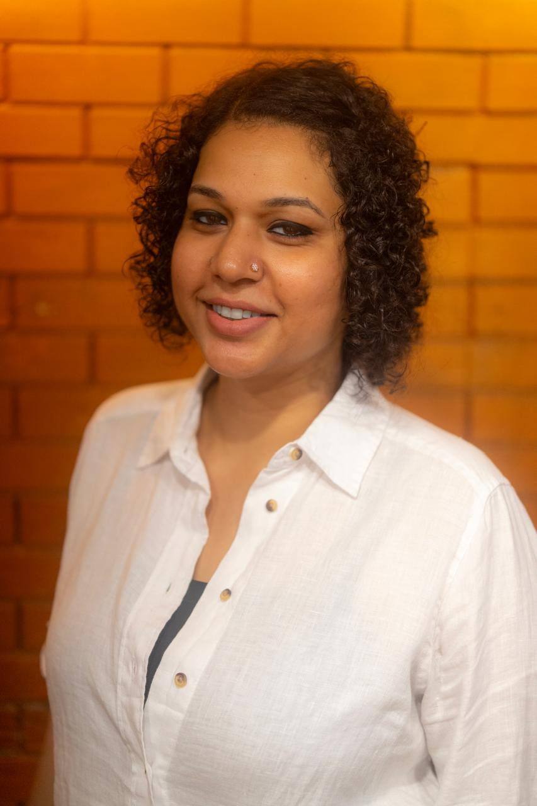
Rabia brings a deep commitment to supporting women in the media industry, leading the development building the foundation of WIF India. With 15 years of experience in program management and gender advocacy, Rabia plays a pivotal role in overseeing partnerships, strategic planning, and industry engagement, ensuring that the program bridges the gap between talent and opportunity for women in the industry.
Diya Panjwani
Project Coordinator
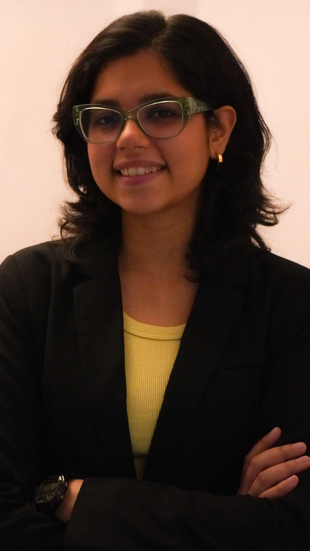
Diya provides crucial support in coordinating all aspects of bringing the team together and administrating WIF India. Her excellent organizational skills help maintain timelines and streamline communication between the team and external partners. Diya’s role ensures that the program’s operations run smoothly and that all team efforts are aligned with the program’s goals.
Together, this team combines expertise across production, program management, communication, and project coordination to ensure the success and sustainability of WIF India as a transformative resource for the Indian media industry.

THE ADVISORY BOARD
WIF India is guided by an exceptional Board of industry leaders, creators, and changemakers who bring deep expertise, credibility, and vision to our mission. Representing a cross-section of India’s film, media, digital, policy, and corporate sectors, the Board plays a critical role in shaping strategy, ensuring accountability, and amplifying the impact of our programs.
Their collective experience and commitment ensure that WIF India remains connected to the realities of the industry while pushing forward a progressive, inclusive agenda for the future.

Board Members:
- Anupama Chopra – Film Journalist
- Aparna Purohit – Producer, Aamir Khan Films
- Ekta Kapoor – Producer, Balaji Telefilms
- Faye D’Souza – Journalist & News Anchor
- Gayatri Yadav – Group CMO and EVP Strategic Initiatives, Chairman’s Office, Reliance
- Gauri Shinde – Director & Screenwriter
- Guneet Monga Kapoor – Producer, Oscar Winner & Board Chair, WIF India
- Jyoti Deshpande – Producer and President, media and content Business, Reliance
- Kanika Dhillon – Screenwriter & Producer
- Karan johar – Director, Producer & Studio Head
- Miriam Joseph – Producer
- Nikhil Advani– Director & Producer
- Siddharth Roy kapur – Producer & Former President, Producers Guild
- Tahira Kashyap – Filmmaker & Author
- Twinkle Khanna – Author, Columnist & Producer
- Varun Grover – Writer, Lyricist
- Vani Tripathy – Actor

THE INTERNSHIP PROGRAM

Creating Tangible Pathways to Work for Women in Film, TV, and Digital Media
The Employment pillar of WIF India focuses on enabling real, sustained workforce participation for women at all career stages. While mentorship and training are critical, true empowerment lies in providing access to paid work, career continuity, and creative ownership. This vertical aims to directly place women into the workforce, support their creative outputs, and incentivize inclusive hiring across the industry.

Internships (100 Women over 3 years)
Duration: 6 months
Departments Covered:
- Direction & Assistant Direction
- Writing & Script Supervision
- Editing & Post-Production
- Production Coordination & Line Production
- Costume & Art Departments
- Talent Management & Casting
- Entertainment Law & Contracts
- OTT Platforms & Channel Programming
- Production Design & Cinematography
Support Includes:
- Paid stipends, ensuring internships are accessible to all, not just those who can afford unpaid roles
- Travel and accommodation support (especially for interns from smaller towns or non-metro backgrounds)
- Host mentorship, with trained professionals guiding interns throughout the engagement
- Certificates, recommendation letters, and evaluation reports at the end of each term
Goal:
To ensure 100 women over 3 years get their foot in the door across 10+ core departments of the media industry, with many transitioning into full-time roles post-internship.

Budget Overview (Annual)

Line Item | Description | Amount
Stipends | ₹20,000/month for 6 months for 35 Interns from A list Film Institutes | ₹50 Lakhs
Support team | For research, HR & Placement | ₹60 0 Lakhs
Host Mentor Honorariums |  | ₹30 Lakhs
INTERNSHIPS | Paid internships across 10+ departments | ₹2.3 Cr

IMPACT FRAMEWORK

Key Metrics Tracked Annually
- Number of women placed in internships
- Number of production houses hiring women
- Overall employment growth in women-led units

Projected Impact by Year 3
- 100+ internships completed
- 50 production companies earn WIF India gender-forward badge

MONITORING & EVALUATION TOOLKIT
WIF India will implement a robust M&E framework that includes:
- Pre- and post-program surveys for interns and lab attendees
- Hiring and promotion tracking within studios we engage
- Internship completion and conversion logs
- Employer and mentor feedback reports
- Annual WIF India Gender Employment Report
- Third-party impact audit (Year 3) for transparency

CONCLUSION
This proposal is not just about employment, it is about systemic inclusion, creative representation, and economic empowerment for women in Indian media.
We request an annual commitment of ₹2.5 crores from the Ministry of Information & Broadcasting to deliver:
- Scalable, measurable employment outcomes
- Increased representation of Indian women filmmakers
- Lasting change in hiring practices across the entertainment ecosystem

WIF India Proposes a Closing Ceremony to Mark the Completion of the Program
At the conclusion of the six-month internship program, WIF India will host a formal closing event to celebrate the achievements of the participants. During this event, all interns will receive certificates acknowledging their successful completion of the program. These certificates will feature the Kamla Mills Foundation logo and will be co-signed by representatives from the partner production house and WIF India.
We would be honoured to invite a representative from the Kamla Mills Foundation, ideally the Founder to personally present the certificates, alongside a WIF India Board Member. This event will also serve as a public platform to showcase the Foundation’s meaningful contribution toward advancing employment opportunities for young women in the Indian film industry. The visibility from this moment will add significantly to Kamla Mills Foundation’s impact narrative and public credentials as a champion of gender equity and workforce development.
Let’s get more women more jobs — and together, change the story.

